2017-19 Biennium Budget
Decision Package

Agency: 355 – Dept. of Arch and Hist Preservation

Decision Package Code/Title: AK - 17 19 IT Maintenance

Budget Period: 2017 - 19

Budget Level: PL - Performance Level

Agency Recommendation Summary Text:

The Department of Archaeology and Historic Preservation (DAHP) is requesting IT maintenance funding for data storage and backup increases and virtual server costs over the next biennium. This funding will positively impact Results WA Goal 5, Customer Confidence 3.1.a., Timely Delivery of Services 1.2, Customer Satisfaction 1.1.a. (which requires an increase in customer service on line) and confidently effects Lean Engagement 2.1a. With this funding DAHP will continue to provide the current level of services and meet the increasing demand for data storage and backups associated with the agency’s data sharing program with local governments and on-line Washington Information System for Architectural and Archaeological Records Data (WISAARD) application; which is a password protected WEB based, geographic information system (GIS) focused, searchable state cultural resources database. WISAARD was nationally recognized when the system won the American Council of Technology's 2010 Intergovernmental Solutions Award and has currently been nominated for another national Award.

Fiscal Summary: Decision package total dollar and FTE cost/savings by year, by fund, for 4 years. Additional fiscal details are required below.

Operating Expenditures | FY 2018 | FY 2019 | FY 2020 | FY 2021
Fund 001-1 | 49,000 | 53,000 | 57,000 | 63,000
Total Cost | 49,000 | 53,000 | 57,000 | 63,000
Staffing | FY 2018 | FY 2019 | FY 2020 | FY 2021
FTEs | 0.0 | 0.0 | 0.0 | 0.0
Revenue | FY 2018 | FY 2019 | FY 2020 | FY 2021
n/a | 0.0 | 0.0 | 0.0 | 0.0
Object of Expenditure | FY 2018 | FY 2019 | FY 2020 | FY 2021
Obj. E | 49,000 | 53,000 | 57,000 | 63,000

Package Description

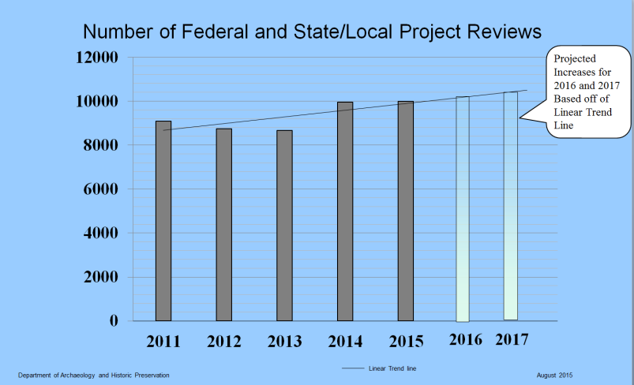
- This decision package is a funding request for storage and backup cost increases and virtual server costs associated with the on-line WISAARD system and virtual server migration into the Washington State Data Center. Over the next biennium, DAHP estimates that over one million state, federal, local, tribal, and private landowners will consult with DAHP on cultural resources with respect to project reviews subject to state and federal law (see Figure 1). As a result virtual server hosting and those project reviews, the department’s email archive will grow at an annual rate of 25%, DAHP’s data backups will increase by 10% each year, and data storage will grow at 20% each year. Currently, this growth rate is not sustainable at DAHP’s present appropriation level.
Base Budget: If the proposal is an expansion or alteration of a current program or service, provide information on the resources now devoted to the program or service. Please include annual expenditures and FTEs by fund and activity (or provide working models or backup materials containing this information).
Figure 1: State, Federal, and Local Project Reviews with Projected Trend line for 2016 and 2017.

- The proposal is neither an expansion nor alteration of a current program or service.

Decision Package expenditure, FTE and revenue assumptions, calculations and details: Agencies must clearly articulate the workload or policy assumptions used in calculating expenditure and revenue changes proposed.

- In collaboration with Washington Technology Solutions (WaTech), cost projections for data storage and backup increases as well as new virtual server costs were calculated from the following:

  - Virtual server CPU, Memory, Storage expenditures are based on current billing rates and include a projected 20% storage growth rate for each fiscal year. The 20% projected storage rate increase was calculated on the actual annual increase over the last fiscal year (15%), plus an additional 5% growth to anticipate 365,000 new photos and pdfs associated with the agency’s state and federal project reviews over the next biennium.

Servers from the 8-15 Inventory
Current | Resources |  |  |  | 20%  Delta | Monthly Cost |  |  | IAAS | IAAS
Server Name | vCPUs | Mem (GB) |  | Strg (GB) | Strg (GB) | Compute | Memory | Storage | Monthly | Yearly total
ssvdbolydahp3 | 8 | 24.0 |  | 825 | 0 | $605.76 | $401.76 | $140.25 | $1,147.77 | $13,773.24
ssvwbolydahpgs3 | 2 | 8.0 |  | 30 | 0 | $151.44 | $133.92 | $5.10 | $290.46 | $3,485.52
ssvflolydahp2 | 4 | 6.0 |  | 1540 | 0 | $302.88 | $100.44 | $261.80 | $665.12 | $7,981.44
ssvapolydahpd3 | 2 | 12.0 |  | 1580 | 0 | $151.44 | $200.88 | $268.60 | $620.92 | $7,451.04
ssvapolydahpv3 | 2 | 12.0 |  | 1590 | 0 | $151.44 | $200.88 | $270.30 | $622.62 | $7,471.44
Total | 18 | 62 |  | 5,565 | 0 | $1,362.96 | $1,037.88 | $946.05 | $3,346.89 | $40,162.68
After 20% Storage Increase |  | 2017
 | Resources |  |  |  | 20%  Delta | Monthly Cost |  |  | IAAS | IAAS | 20%  Delta | IAAS Delta | IAAS Delta
Server Name | vCPUs | Mem (GB) | Strg (GB) |  | Strg (GB) | Compute | Memory | Storage | Monthly | Yearly total + 20% Increase | Strg (GB) | Monthly | Yearly
ssvdbolydahp3 | 8 | 24.0 | 990 |  | 165 | $605.76 | $401.76 | $168.30 | $1,175.82 | $14,109.84 | $28.05 | $1,035.57 | $12,426.84
ssvwbolydahpgs3 | 2 | 8.0 | 36 |  | 6 | $151.44 | $133.92 | $6.12 | $291.48 | $3,497.76 | $1.02 | $286.38 | $3,436.56
ssvflolydahp2 | 4 | 6.0 | 1848 |  | 308 | $302.88 | $100.44 | $314.16 | $717.48 | $8,609.76 | $52.36 | $455.68 | $5,468.16
ssvapolydahpd3 | 2 | 12.0 | 1896 |  | 316 | $151.44 | $200.88 | $322.32 | $674.64 | $8,095.68 | $53.72 | $406.04 | $4,872.48
ssvapolydahpv3 | 2 | 12.0 | 1908 |  | 318 | $151.44 | $200.88 | $324.36 | $676.68 | $8,120.16 | $54.06 | $406.38 | $4,876.56
Total | 18 | 62 | 6,678 |  | 1,113 | $1,362.96 | $1,037.88 | $1,135.26 | $3,536.10 | $42,433.20 | $189.21 | $2,590.05 | $31,080.60

After 20% Storage Increase |  | 2018
 | Resources |  |  | 20%  Delta | Monthly Cost |  |  | IAAS | IAAS | 20%  Delta | IAAS Delta | IAAS Delta
Server Name | vCPUs | Mem (GB) | Strg (GB) | Strg (GB) | Compute | Memory | Storage | Monthly | Yearly total + 20% Increase | Strg (GB) | Monthly | Yearly
ssvdbolydahp3 | 8 | 24.0 | 1188 | 198 | $605.76 | $401.76 | $201.96 | $1,209.48 | $14,513.76 | $33.66 | $1,041.18 | $12,494.16
ssvwbolydahpgs3 | 2 | 8.0 | 43 | 7 | $151.44 | $133.92 | $7.34 | $292.70 | $3,512.45 | $1.22 | $286.58 | $3,439.01
ssvflolydahp2 | 4 | 6.0 | 2218 | 370 | $302.88 | $100.44 | $376.99 | $780.31 | $9,363.74 | $62.83 | $466.15 | $5,593.82
ssvapolydahpd3 | 2 | 12.0 | 2275 | 379 | $151.44 | $200.88 | $386.78 | $739.10 | $8,869.25 | $64.46 | $416.78 | $5,001.41
ssvapolydahpv3 | 2 | 12.0 | 2290 | 382 | $151.44 | $200.88 | $389.23 | $741.55 | $8,898.62 | $64.87 | $417.19 | $5,006.30
Total | 18 | 62 | 8,014 | 1,336 | $1,362.96 | $1,037.88 | $1,362.31 | $3,763.15 | $45,157.82 | $227.05 | $2,627.89 | $31,534.70
After 20% Storage Increase |  | 2019
 | Resources |  |  | Delta | Monthly Cost |  |  | IAAS | IAAS | 20%  Delta | IAAS Delta | IAAS Delta
Server Name | vCPUs | Mem (GB) | Strg (GB) | Strg (GB) | Compute | Memory | Storage | Monthly | Yearly total + 20% Increase | Strg (GB) | Monthly | Yearly
ssvdbolydahp3 | 8 | 24.0 | 1426 | 238 | $605.76 | $401.76 | $242.35 | $1,249.87 | $14,998.46 | $40.39 | $1,047.91 | $12,574.94
ssvwbolydahpgs3 | 2 | 8.0 | 52 | 9 | $151.44 | $133.92 | $8.81 | $294.17 | $3,530.07 | $1.47 | $286.83 | $3,441.95
ssvflolydahp2 | 4 | 6.0 | 2661 | 444 | $302.88 | $100.44 | $452.39 | $855.71 | $10,268.52 | $75.40 | $478.72 | $5,744.62
ssvapolydahpd3 | 2 | 12.0 | 2730 | 455 | $151.44 | $200.88 | $464.14 | $816.46 | $9,797.53 | $77.36 | $429.68 | $5,156.12
ssvapolydahpv3 | 2 | 12.0 | 2748 | 458 | $151.44 | $200.88 | $467.08 | $819.40 | $9,832.78 | $77.85 | $430.17 | $5,162.00
Total | 18 | 62 | 9,616 | 1,603 | $1,362.96 | $1,037.88 | $1,634.77 | $4,035.61 | $48,427.37 | $272.46 | $2,673.30 | $32,079.63

After 20% Storage Increase |  | 2020
 | Resources |  |  | 20%  Delta | Monthly Cost |  |  |  | IAAS | IAAS |  | 20%  Delta | IAAS Delta |  | IAAS Delta
Server Name | vCPUs | Mem (GB) | Strg (GB) | Strg (GB) | Compute | Memory |  | Storage | Monthly | Yearly total + 20% Increase |  | Strg (GB) | Monthly |  | Yearly
ssvdbolydahp3 | 8 | 24.0 | 1711 | 285 | $605.76 | $401.76 |  | $290.82 | $1,298.34 | $15,580.11 |  | $48.47 | $1,055.99 |  | $12,671.88
ssvwbolydahpgs3 | 2 | 8.0 | 62 | 10 | $151.44 | $133.92 |  | $10.58 | $295.94 | $3,551.22 |  | $1.76 | $287.12 |  | $3,445.47
ssvflolydahp2 | 4 | 6.0 | 3193 | 532 | $302.88 | $100.44 |  | $542.87 | $946.19 | $11,354.26 |  | $90.48 | $493.80 |  | $5,925.58
ssvapolydahpd3 | 2 | 12.0 | 3276 | 546 | $151.44 | $200.88 |  | $556.97 | $909.29 | $10,911.47 |  | $92.83 | $445.15 |  | $5,341.78
ssvapolydahpv3 | 2 | 12.0 | 3297 | 550 | $151.44 | $200.88 |  | $560.49 | $912.81 | $10,953.77 |  | $93.42 | $445.74 |  | $5,348.83
Total | 18 | 62 | 11,540 | 1,923 | $1,362.96 | $1,037.88 |  | $1,961.73 | $4,362.57 | $52,350.83 |  | $326.95 | $2,727.79 |  | $32,733.54
After 20% Storage Increase |  | 2021
 | Resources |  |  | 20%  Delta | Monthly Cost |  |  |  | IAAS | IAAS | 20%  Delta |  | IAAS Delta | IAAS Delta
Server Name | vCPUs | Mem (GB) | Strg (GB) | Strg (GB) | Compute | Memory | Storage |  | Monthly | Yearly total + 20% Increase | Strg (GB) |  | Monthly | Yearly
ssvdbolydahp3 | 8 | 24.0 | 2053 | 342 | $605.76 | $401.76 | $348.99 |  | $1,356.51 | $16,278.08 | $58.16 |  | $1,065.68 | $12,788.21
ssvwbolydahpgs3 | 2 | 8.0 | 75 | 12 | $151.44 | $133.92 | $12.69 |  | $298.05 | $3,576.61 | $2.12 |  | $287.48 | $3,449.70
ssvflolydahp2 | 4 | 6.0 | 3832 | 639 | $302.88 | $100.44 | $651.44 |  | $1,054.76 | $12,657.15 | $108.57 |  | $511.89 | $6,142.72
ssvapolydahpd3 | 2 | 12.0 | 3932 | 655 | $151.44 | $200.88 | $668.36 |  | $1,020.68 | $12,248.19 | $111.39 |  | $463.71 | $5,564.57
ssvapolydahpv3 | 2 | 12.0 | 3956 | 659 | $151.44 | $200.88 | $672.59 |  | $1,024.91 | $12,298.95 | $112.10 |  | $464.42 | $5,573.03
Total | 18 | 62 | 13,848 | 2,308 | $1,362.96 | $1,037.88 | $2,354.08 |  | $4,754.92 | $57,058.98 | $392.35 |  | $2,793.19 | $33,518.23
Assumptions:
Pay as you Go Pricing without dedicated resources. Includes IaaS only - no technical support for the operating systems. SQL Licensing for production servers not included. Does not include backup and recovery. Dollar amounts calculated based on $0.17 per GB rate.

- Email archive expenditure was based on June 2016 billing information and limited only to the projected growth rate of 25% each biennium. - This projected growth rate was calculated from last years observed growth; which was roughly 25%.

Item Description | Unit | Total | Expected 25% Monthly Increase 2017 | Expected Yearly Changes 2017 %only | Total Actual  2017 | Expected Yearly Changes 2018 %only | Total Actual  2018 | Expected Yearly Changes 2019 %only | Total Actual  2019 | Expected Yearly Changes 2020 %only | Total Actual  2020 | Expected Yearly Changes 2021 %only | Total Actual  2021
NEARLINE STORAGE-WASERV | GB/MTH | $447.04 | $112 | $1,341 | $6,705.60 | $1,676.40 | $8,382.00 | $2,095.50 | $10,477.50 | $2,619.38 | $13,096.88 | $3,274.22 | $16,371.09

  - DAHP’s data storage backup expenditure is based on June 2016 billing information and is limited only to the projected growth rate of 10% each biennium. – This rate was calculated on the actual annual increase over the last fiscal year (5%), plus an additional 5% growth to anticipate 365,000 new photos and pdfs associated with the agency’s state and federal project reviews over the next biennium.

Item Description | Unit | Total | Expected 10% Monthly Increase 2017 | Expected Yearly Changes 2017 %only | Total Actual  2017 | Expected Yearly Changes 2018 %only | Total Actual  2018 | Expected Yearly Changes 2019 %only | Total Actual  2019 | Expected Yearly Changes 2020 %only | Total Actual  2020 | Expected Yearly Changes 2021 %only | Total Actual  2021
AVAMAR SYSTEM | GB/MTH | $1,450.86 | $145 | $1,741 | $19,151.35 | $1,915.14 | $21,066.49 | $2,106.65 | $23,173.14 | $2,317.31 | $25,490.45 | $2,549.04 | $28,039.49

Decision Package Justification and Impacts
What specific performance outcomes does the agency expect?

- The agency expects to outperform the last biennium’s performance measures. Please see below for more detail.

Performance Measure detail:

Fully describe and quantify expected impacts on state residents and specific populations served.

Activity: | Incremental Changes
Measure 001386 - Number of Properties newly entered into the Archaeological and Historic sites database | DAHP is well above target for last biennium’s performance measure and is expected to enter more than 12,944 cultural resources in the next biennium. As the agency’s data footprint grows each year, so do the increases in costs accompanying the virtual servers and data storage and backup that house the data. This is the largest factor driving this funding request.  The increased documentation associated with these cultural resources directly impact the agency’s data footprint; which is anticipated to grow 25% in email archiving, 20% data storage, and 10% in data backups each year.

Measure 001395 - Percentage of Federal project reviews completed within statutory 30-day deadline | This performance measure represents the number of federal projects reviewed within the 30 day review period. In the next bienium, WISAARD will allow DAHP to be involved in project reviews earlier in the process with all of the necessary project documentation; which is estimated to move DAHP closer to 100% project reviews within the 30-day deadline.  The increased project documentation and government transparency associated with these reviews directly impact the agency’s data footprint; which is anticipated to grow 25% in email archiving, 20% data storage, and 10% in data backups each year.  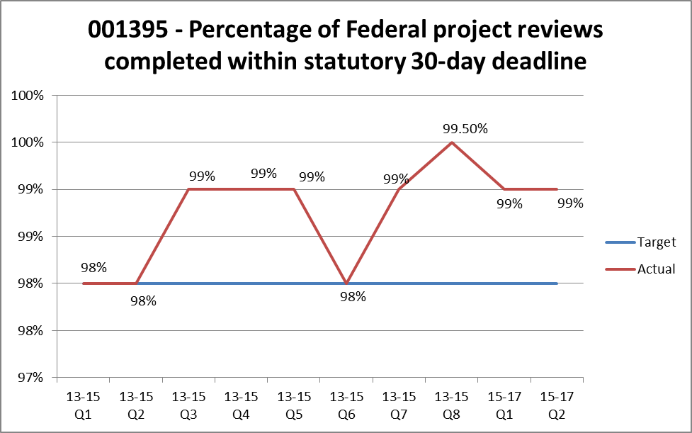  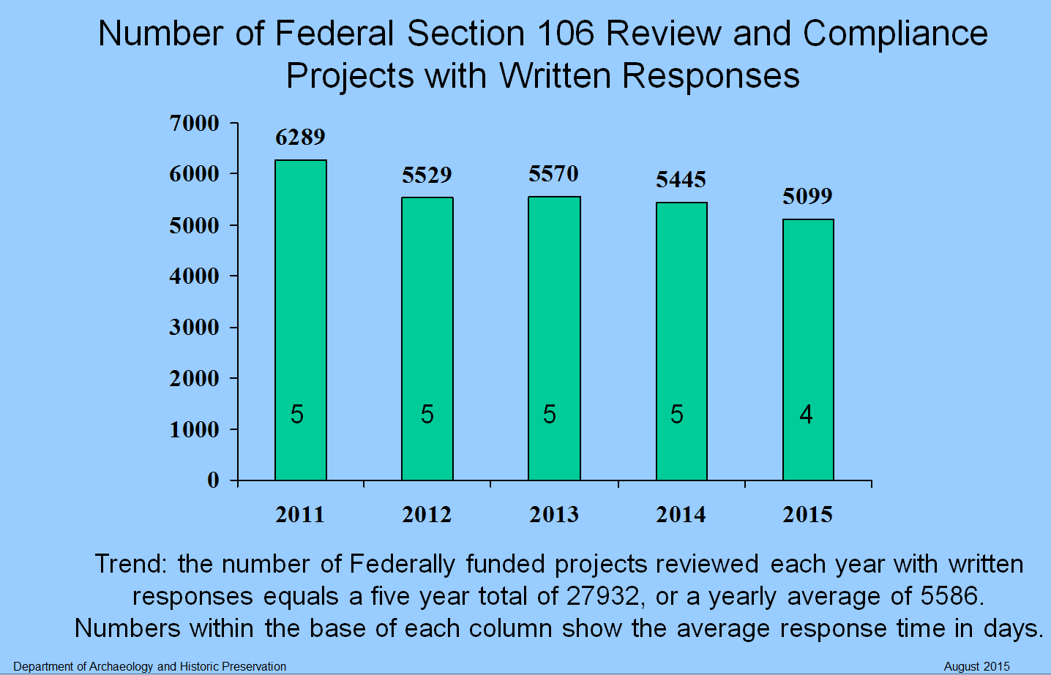
Measure 001402- Percentage of transportation project reviews completed within statutory 30-day deadline | This performance measure represents the number of transportation projects reviewed within the 30 day review period. In the next bienium, WISAARD will allow DAHP to be involved in project reviews earlier in the process with all of the necessary project documentation; which is estimated to move DAHP closer to 100% project reviews within the 30-day deadline.  The increased project documentation and government transparency associated with these reviews directly impact the agency’s data footprint; which is anticipated to grow 25% in email archiving, 20% data storage, and 10% in data backups each year.  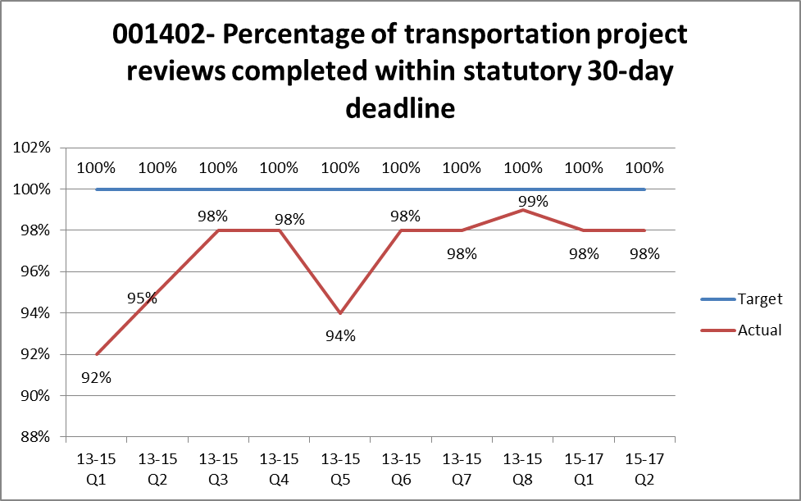

Measure 001407 - Number of Local projects Reviewed | This performance measure represents the number of local government projects reviewed within the 30 day review period. DAHP is expected to review more than 11,037 local governmental projects in the next biennium.  The increased project documentation and government transparency associated with these reviews directly impact the agency’s data footprint; which is anticipated to grow 25% in email archiving, 20% data storage, and 10% in data backups each year.  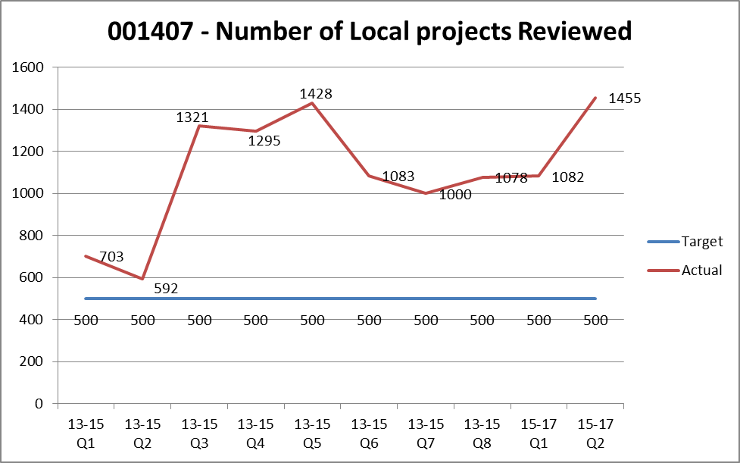  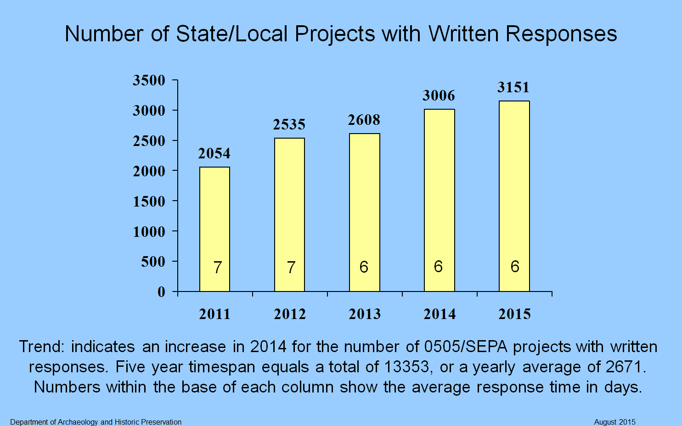

What are other important connections or impacts related to this proposal? Please complete the following table and provide detailed explanations or information below:

Impact(s) To: |  | Identify / Explanation
Regional/County impacts? | Yes | Identify: DAHP data and backups are essential to providing project review under state and federal law to all regional and county governments.
Other local gov’t impacts? | Yes | Identify: DAHP data and backups are essential to providing project review under state and federal law to all local governments.
Tribal gov’t impacts? | Yes | Identify: DAHP data and backups are essential to providing project review under state and federal law to all tribal governments.
Other state agency impacts? | Yes | Identify: DAHP data and backups are essential to providing project review under state and federal law to all of Washington State’s citizens, as well as tribal, municipal, county, state, and federal governments.
Responds to specific task force, report, and mandate or exec order? | Yes | Identify: Section 106 of the National Historic Preservation Act of 1966  Executive Order 05-05 and Executive Order 14-04  RCW 27.44, 68.04, 27.34, and WAC 25-48
Does request contain a compensation change? | No | Identify: This request is a means of sustaining data and storage growth.
Does this request require a change to a collective bargaining agreement? | No | Identify:
Facility/workplace needs or impacts? | No | Identify:
Capital Budget Impacts? | No | Identify:
Is change required to existing statutes, rules or contracts? | No | Identify:
Is the request related to or a result of litigation? | No | Identify lawsuit (please consult with Attorney General’s Office):
Is the request related to Puget Sound recovery? | No | If yes, see budget instructions Section 14.4 for additional instructions
Identify other important connections

Please provide a detailed discussion of connections/impacts identified above.

State and federal law mandates that DAHP be the central repository of cultural resource data. The agency manages over ten types of cultural resources that are maintained through two enterprise level Microsoft SQL databases, such as the State Archaeological Site and Historic Property Inventory datasets, and three official registers of historic places; the National Register of Historic Places, Washington Heritage Register, and the Washington Heritage Barn Register.

These inventories and registers are used by federal and state agencies, local governments and Tribes for compliance with federal and state cultural resource management laws and regulations; particularly the State Environmental Policy Act, Section 106 of the National Historic Preservation Act of 1966, and Executive Order 05-05. Planning and environmental consulting firms use the information for project development as well as property owners, developers, and the general public. The Department of Natural Resources uses the Archaeological Site database as part of the Forest and Fish requirement under their Habitat Conservation Plan to ensure that archaeological sites are not impacted during forest practices activities.

The agency has information on close to 40,000 archaeological sites, 3,000 cemeteries and burials, and over 600,000 historic structures, which increase by one to two thousand, or more, per year. Maintaining and making this data accessible to the public, government agencies and qualified stakeholders is critical to state and federal environmental regulatory review processes as well as for timely project delivery.

Funding for data storage and backup increases and virtual server costs for the next biennium means that the DAHP is able to maintain its current level of customer service, transparency, as well as grow with WISAARD as more users access the online application for review and data input of their cultural resource information. Increased funding for data storage and recovery and virtual server costs will ensure that the agency’s regulatory functions will not be severely impacted in a disaster recovery situation, as the agency will quickly restore data and communications as to the presence or absence of cultural resources (archaeological sites, historic sites, burials etc.), which protects project proponents and other governmental review authorities from risk.

What alternatives were explored by the agency and why was this option chosen?

Since 2003, DAHP has relied on physical servers to host crucial business data. The cost of supporting the four year life cycle and large storage arrays, which the agency constantly outgrew, was becoming cost prohibitive.

Fortuitously, WaTech recently began offering a service for private cloud virtual server hosting that was recommended to meet the agency’s immediate need as well as help circumnavigate the reoccurring cost prohibitive issues that accompanied physical servers.

As a result, the agency elected to reduce its server carbon footprint and reduce immediate costs by migrating all of the expensive physical servers and attached storage into WaTech’s virtual server hosting platform. Not only was this migration off of physical servers and into the cloud a means of complying with recommendations from WaTech and the OCIO strategic planning, but this move enabled DAHP to further reduce the agency’s carbon footprint and conform to the Governor’s Carbon Pollution Executive Order (14-04).

What are the consequences of not funding this request?

By not funding this request, the Dept. of Archaeology and Historic Preservation will not be able to review projects associated with the State Environmental Policy Act, Section 106 of the National Historic Preservation Act of 1966, and Executive Order 05-05 in a timely manner, which will directly impact private citizens of Washington State, as well as state, federal, local, and tribal governments.

If DAHP is unable to pay for additional virtual server infrastructure costs, nor receive and store data associated with project reviews subject to the aforementioned laws, the State of Washington is in breach of those laws and the financial and judicial liability associated with the destruction of cultural resources will fall on the State of Washington and the project proponents.

Damages to Washington State’s non-renewable cultural resources leverage civil penalties, large fines, expensive restoration costs, a class C felony designation under certain circumstance, as well as restitution associated with inflicted pain and suffering to tribal cultural identity.

How has or can the agency address the issue or need in its current appropriation level?

Unfortunately, as more information has become available to the public and appropriate land managers via WISAARD, DAHP’s digital data imprint has only grown larger. There is no way around the anticipated increase in data storage and backup costs over the next biennium.

On the other hand, the current appropriation would address the funding issue if WaTech was able to reduce the cost of their current service offerings.

Other supporting materials: Please attach or reference any other supporting materials or information that will help analysts and policymakers understand and prioritize your request.

Information technology: Does this Decision Package include funding for any IT-related costs, including hardware, software, services (including cloud-based services), contracts or IT staff?
☐ No
☒ Yes Continue to IT Addendum below and follow the directions on the bottom of the addendum to meet requirements for OCIO review.)

IT Addendum

Part 1: Itemized IT Costs
Please itemize any IT-related costs, including hardware, software, services (including cloud-based services), contracts (including professional services, quality assurance, and independent verification and validation), or IT staff. Be as specific as you can. (See chapter 12.1 of the operating budget instructions for guidance on what counts as “IT-related costs”)

Information Technology Items in this DP | FY 2017 | FY 2018 | FY 2019 | FY 2020 | FY 2021
1736 - NEARLINE STORAGE-WASERV | 1,000 | 2,000 | 2,000 | 3,000 | 3,000
1738 - SERVER BACKUP SERVICE (Avamar) | 2,000 | 2,000 | 2,000 | 2,000 | 3,000
1741 - CTS SERVER HOSTING-PRIVATE CLOUD IN | 42,000 | 45,000 | 49,000 | 52,000 | 57,000
Total Cost | 45,000 | 49,000 | 53,000 | 57,000 | 63,000

Part 2: Identifying IT Projects
If the investment proposed in the decision package is the development or acquisition of an IT project/system, or is an enhancement to or modification of an existing IT project/system, it will also be reviewed and ranked by the OCIO as required by RCW 43.88.092. The answers to the three questions below will help OFM and the OCIO determine whether this decision package is, or enhances/modifies, an IT project:

- Does this decision package fund the development or acquisition of a ☐Yes ☒ No
new or enhanced software or hardware system or service?

- Does this decision package fund the acquisition or enhancements ☐Yes ☒ No
of any agency data centers? (See OCIO Policy 184 for definition.)

- Does this decision package fund the continuation of a project that ☐Yes ☒ No
is, or will be, under OCIO oversight? (See OCIO Policy 121.)

If you answered “yes” to any of these questions, you must complete a concept review with the OCIO before submitting your budget request. Refer to chapter 12.2 of the operating budget instructions for more information.

