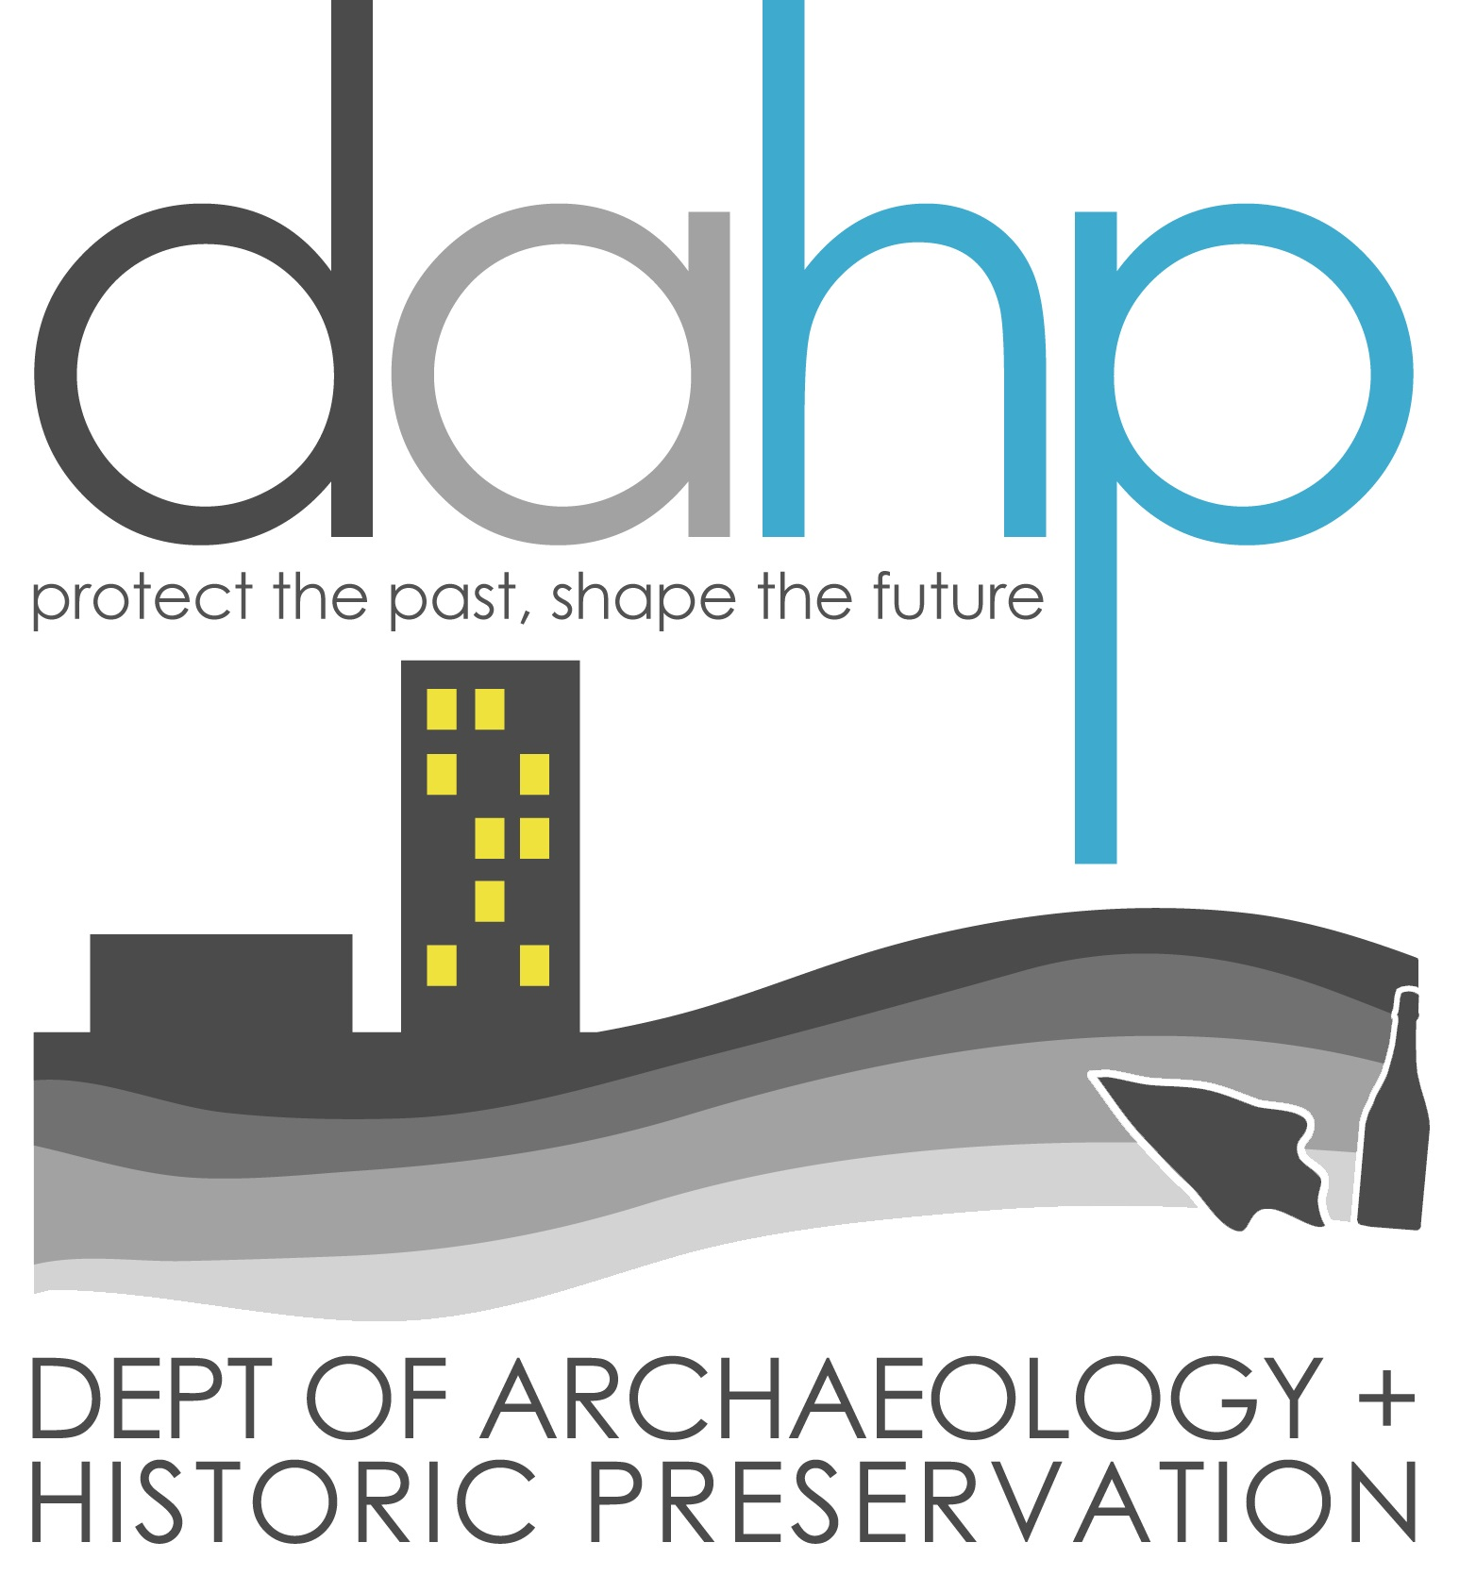
ABANDONED CEMETERIES CARE AND MAINTENANCE CERTIFICATE APPLICATION

This application is to be used by non-profit organizations and state or local government organizations wishing to restore, protect or maintain an abandoned cemetery under the provisions of RCW 68.60. If you have questions about the form, please contact Guy Tasa at the Department of Archaeology and Historic Preservation, P.O. Box 48343, Olympia, Washington 98504-8343, (360) 790-1633, guy.tasa@dahp.wa.gov.

- APPLICANT ORGANIZATION IDENTIFICATION

Check One:

Express Purpose Non-Profit Corporation
Other Non-Profit Corporation
State, Tribal, or Local Government Organization

Name:
Address:
City: State: Zip:

Contact Person:
Telephone:

If you are a non-profit corporation enclose a copy of your corporate charter or articles of incorporation documenting your non-profit status. If one of the purposes of your organization is the restoration, maintenance or protection of an abandoned cemetery, be sure to include those articles.

- PROJECT CEMETERY

Name:

Location (including but not limited to Township, Range and Section):

Township: Range: Section:
Other locational Information (Address, Parcel No., etc..):

Boundary Description:

Please enclose a copy of the cemetery boundary map and
a USGS Quad map showing the location of the cemetery.

3. EVIDENCE OF ABANDONMENT

Enclose one or more of the following documents/letters:

Statement of the county assessor attesting that no record of the owner has been found;

Statement of the county assessor that the last known owner is deceased and lawful conveyance of the title has not been made;

Evidence that the cemetery company, association, corporation or other organization formed for burying the dead has disbanded or been administratively dissolved by the secretary of state, or no longer has a valid certificate of authority as determined by the funeral and cemetery board.

4. PROJECT DESCRIPTION

Please briefly describe the activities your organization intends to conduct at the cemetery identified in this application:

What is the planned frequency of these activities (for example, monthly, quarterly, annually)?

If you plan to alter or add any memorials, roadways, plantings or other features, please describe the alterations:

How many individuals do you estimate will be involved in the activities at any one time?

5. CERTIFICATION OF APPLICANT

I certify that all information given herein is correct; that I have been authorized by the applicant organization identified above to submit this application on behalf of the organization and that all activities carried out under this application will be in accordance with such state statutes as may be in effect at the time the authority is granted, including but not limited to RCW 68.60 and RCW 27.53.

I acknowledge that pursuant to RCW 68.60.030 any grant of authority shall be limited to the care, maintenance, restoration, protection, and historical preservation of the abandoned cemetery, and shall not include authority to make burials. I further acknowledge that an archaeological excavation permit issued under RCW 27.53 may be required for care and maintenance activities that require ground disturbance.

Signature:______________________________________ Date: ________________

Typed or printed name:

Signature: ______________________________________ Date: ________________

Typed or printed name:

Send the completed application and required attachments to:

Department of Archaeology and Historic Preservation
Attn: Guy Tasa, State Physical Anthropologist
P.O. Box 48343
Olympia, Washington 98504-8343

