Washington State Department of
Archaeology & Historic Preservation

State Historic Preservation Officer’s 28th Annual Awards
Outstanding Achievement in Historic Preservation

NOMINATION FORM
Name of the Project , Organization, Place, or Person being Nominated.

Address, City, Zip Code of Project, Organization, Place, or Person being Nominated.

For a person, Nominee’s Phone Number:

Nominee’s Email:
What County is the Project, Organization, Place or Person in?
Indicate nomination award category. Check only one category per nomination:

Barn Rehab Award
Career Achievement Award
Cemetery Preservation Achievement
Education Award
Historic Preservation Stewardship
Media Award
Preservation Planning Award
Special Achievement Award
Valerie Sivinski Rehab Award

Name of Contact person submitting this nomination

Contact person’s address | Contact person’s Phone  Contact person’s Email
Nominated By (if different Contact Person)
Name
Address | Phone  Email
Return additional materials to
Name

Address | Phone  Email

Nomination Instructions
Submit your nomination with the form provided. You may submit as many nominations as you like, however, please use a separate form for each submission.

Nominations will be accepted until Friday, March 1, 2019.

- State clearly why the individual, organization, or project deserves recognition in the specified category.
- Submit additional material (i.e., photographs, publications, slides, letters of support, etc.) that will help supplement your nomination. Be sure to indicate whether the additional materials should be returned.
- Include your name, address, and telephone in the space marked “Nominated by”. If someone other than you is to be notified of the status of the nomination or award, please include that information in the “Contact Person” section.
- The State Historic Preservation Officer (SHPO) may choose to select more than one award winner in each category and reserves the right not to choose an award winner within a category. The SHPO reserves the right to move a nomination into a category that is different than the one indicated on the form if it appears that another category is more appropriate.
Please submit your nominations to

Beva Ubias
Washington State Department of Archaeology & Historic Preservation
P O Box 48343
Olympia WA 98504-8343 or electronically to Beverly.ubias@dahp.wa.gov

If you have any questions, please contact Beverly Ubias at 360.586.3077
Beverly.ubias@dahp.wa.gov or for technical questions, Holly Borth at 360.586.3533 holly.borth@dahp.wa.gov

The State Historic Preservation Officer will present the awards at a ceremony on

Date Thursday, May 30, 2019
Time 1-3 pm
Place State Reception Room, 3rd floor
Legislative Building (State Capitol Bldg)
416 Sid Snyder Avenue SW
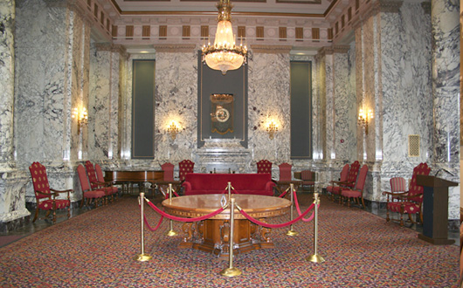
Olympia WA 98504
